Step-1 create database nest_data:

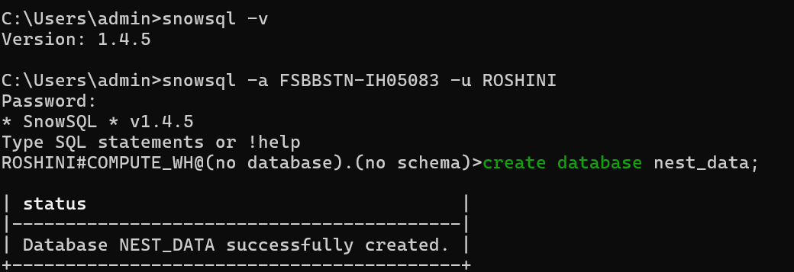

Step-2 create schema csv_schema;

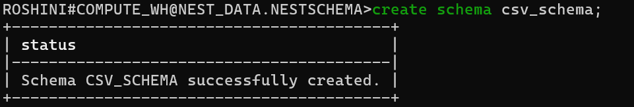

Step-3 create table csv_table(id int,name varchar(100),dept varchar(100),email varchar(100));

Step-4 create or replace stage stage_csv;

Step-5 put 'file://C:/snow_assignment1/employee-1.csv' @stage_csv;

Step-6 CREATE OR REPLACE FILE FORMAT csv_flatfile TYPE = 'CSV'
FIELD_DELIMITER = SKIP_HEADER = 1;

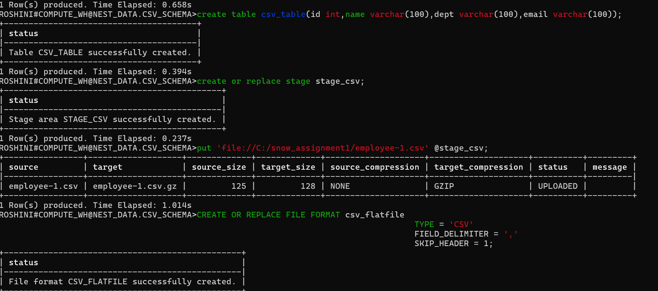

Step-7 COPY INTO CSV_TABLE
FROM @stage_csv/employee-1.csv
FILE_FORMAT = (FORMAT_NAME = CSV_FLATFILE)
ON_ERROR = 'CONTINUE';

Step-8 select * from CSV_TABLE;





